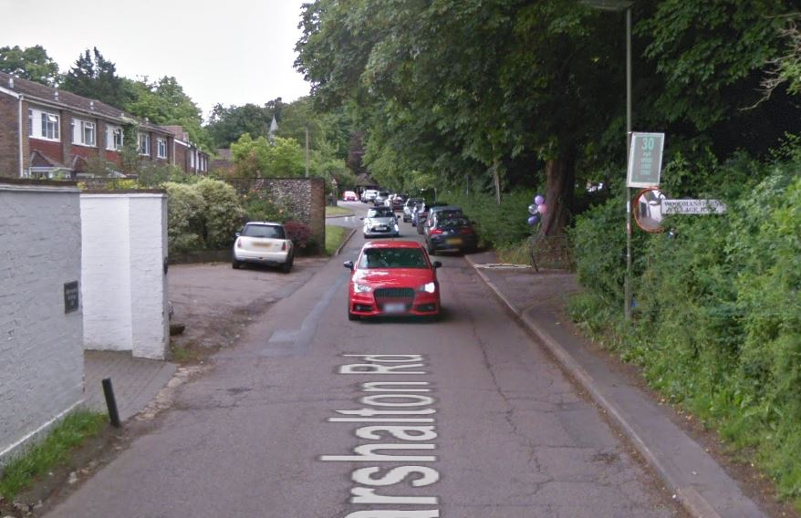
Entrance is on the right hand sde. It is signposted.

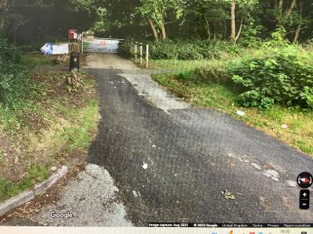
Entrance to Woodmansterne Vilage Hall

